
Savitribai Phule Pune University
Interdisciplinary School of Scientific Computing (ISSC)

Mid Semester Exam.- III Nov.2018

Course No. : SC - 104

Title : Foundation of Scientific Computing - II

Date : 3 Nov. 2018
Time : 10:30am to 12:00noon Marks : 30
______________________________________________________________________________

Q.1. (a) Evaluate any two integrals. ( 2 marks each.)

(i) 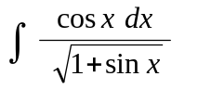 (ii) 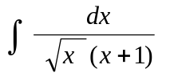 (iii) 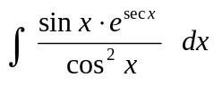

(b) Evaluate the integral. (3)

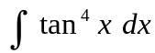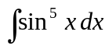

(c) Evaluate the integral. (3)
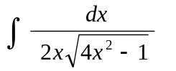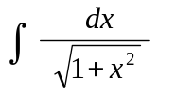

Q.2. (a) Evaluate the integral. (3)
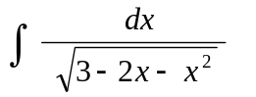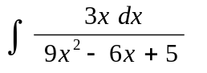

(b) Evaluate the integral. (4)

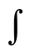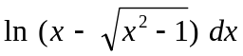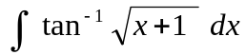
(c) Evaluate any one integral. (4)

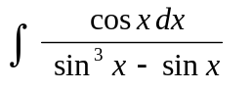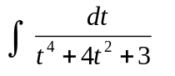

Q.3 (a) Evaluate the integral. (3)

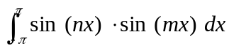 for different integer values of and 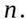

(b) Compute the area bounded by given curves and lines. (Any one.) (3)

(P.T.O)

- 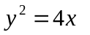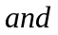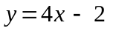
- 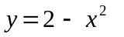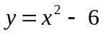

(c) Show that the perimeter of circle of radius 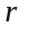is 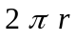 units. (2)

Find the length of the curve. (3)





